Sign Language Recognition System

USER MANUAL

INDEX

1. Getting started. Pg...3
2. Configuration.

Pg...4

1. Starting the Application and Understanding the Graphical User Interface.

Pg...5

1. Gestures and understanding the output.

Pg...6

Getting Started

Before starting the installation of the program do check with the system requirements to prevent malfunction.

**System Requirements**

External device: camera  
Processor: Pentium/AMD  
Speed: 233MHz  
Ram: 512MB  
Hard disk: 40GB

The requisite soft wares have been stated above, please install them through the CD provided or if not available go to the following links and download them.

1. Visual Studio 2010 -[www.microsoft.com](http://www.microsoft.com) (for programmers who want to modify the code).
2. OpenCV - [www.opencv.org](http://www.opencv.org)

After installing these soft wares you are ready to install our system onto your computer.

Configuration

The software application developed has been made to run in a windows environment. Initial setup requires you to unpack the files in the compressed form (.rar or .zip) using a software like WinZip/WinRar.

Also make sure the directories are in the following drives and have the same Path (without quotes) :

OpenCVpath:

“C:\OpenCV_v2.2”

After the extraction is done just click on the SLRS.exe file to run the software.

Also do check that your webcam is in working condition and has the requisite drivers installed on the computer.

Starting the Application and Understanding the Graphical User Interface

Clicking on the SLRS.exe file will begin the application.

On starting the application you will be greeted with a GUI as shown below:

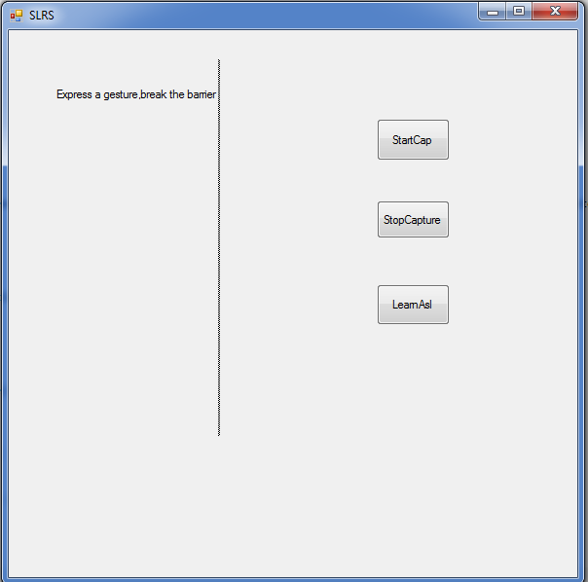

The GUI consists of:

1. Start - This will start the program for sign language recognition.(requires camera)
2. Stop - This will stop the program and return to the GUI.
3. ASL Chart - Shows the different signs belonging to the American Sign Language (for reference).
4. Red Close Button - This will exit the program and close the window, returns the user to the desktop.

Gestures and Understanding the Output

On clicking the Start button the application will execute bringing up a new window.

In this window your cameras input feed will be shown to you, and you will have to form a gesture; the gestures must be one from the ASL chart provided within the program. ASL chart can be seen by clicking the respective button.

Now the small blue dash that can be seen on the output along with your webcam feed is where the text for the gesture will appear.

Once a match is detected then the dash ( “ - “ ) will change to a certain value like ( “ Gesture 5 “ ), in this way you can get the output for the desired hand gesture on the output screen.

For reference consider the screenshot below: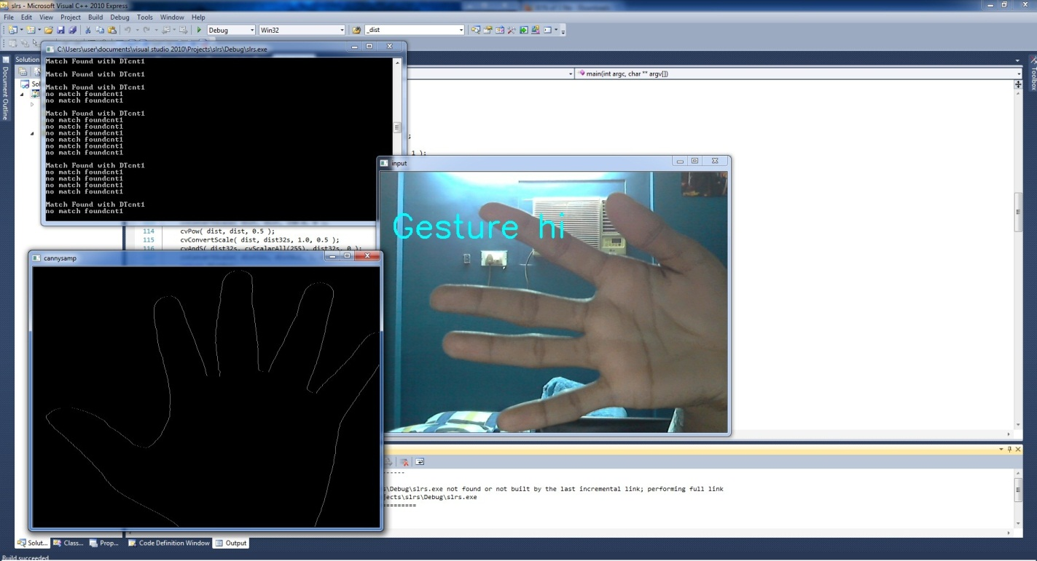

Do notice the hand orientation is not from the bottom which shows the orientation is not a necessary factor for gesture detection and recognition.